Week 2
Q1. Design Seasonal Greeting cards using MS-PowerPoint.
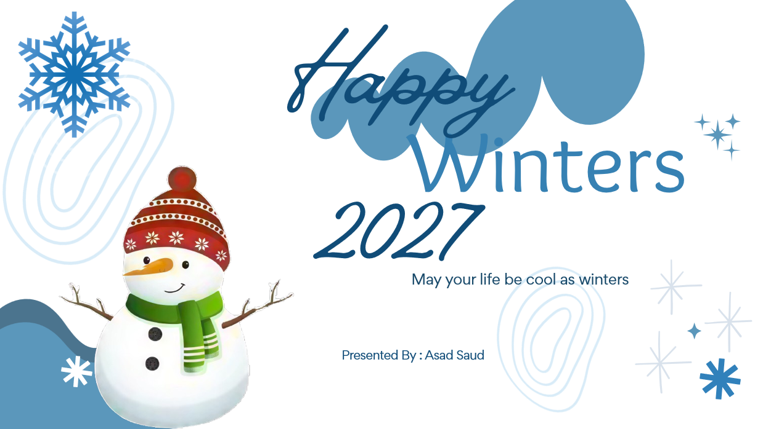
Q2. Design an AMU Magazine cover in MS PowerPoint. Use the following:
- Select a theme for the page.
- Insert either a picture or clipart.
- Use WordArt

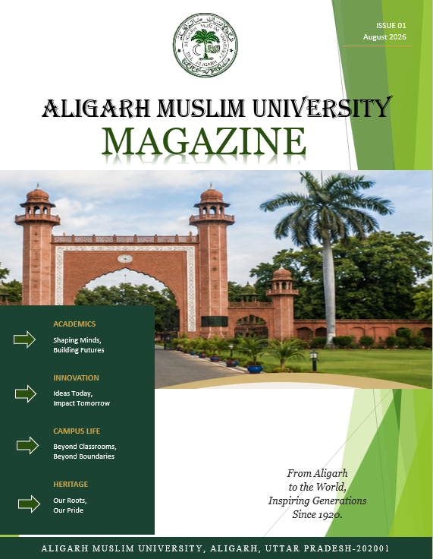

Q3. Design a poster inviting all students of your department to the IT Fest (using MS-Power Point).
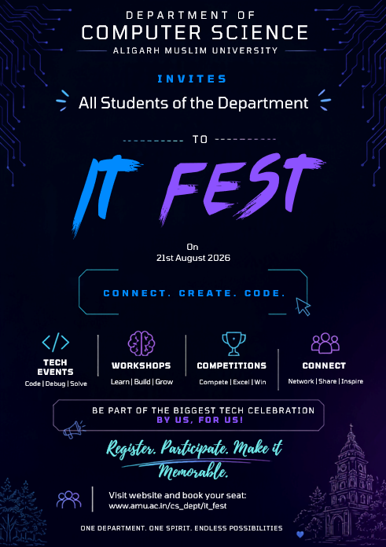
Q4. Create a 5-slide presentation on any topic. Use Images, Graphs, Chart, Tables, Animation, Time, Bullets, Transition, Sound, Hyperlink, Background template, Header and Footer (using MS-Power Point).

